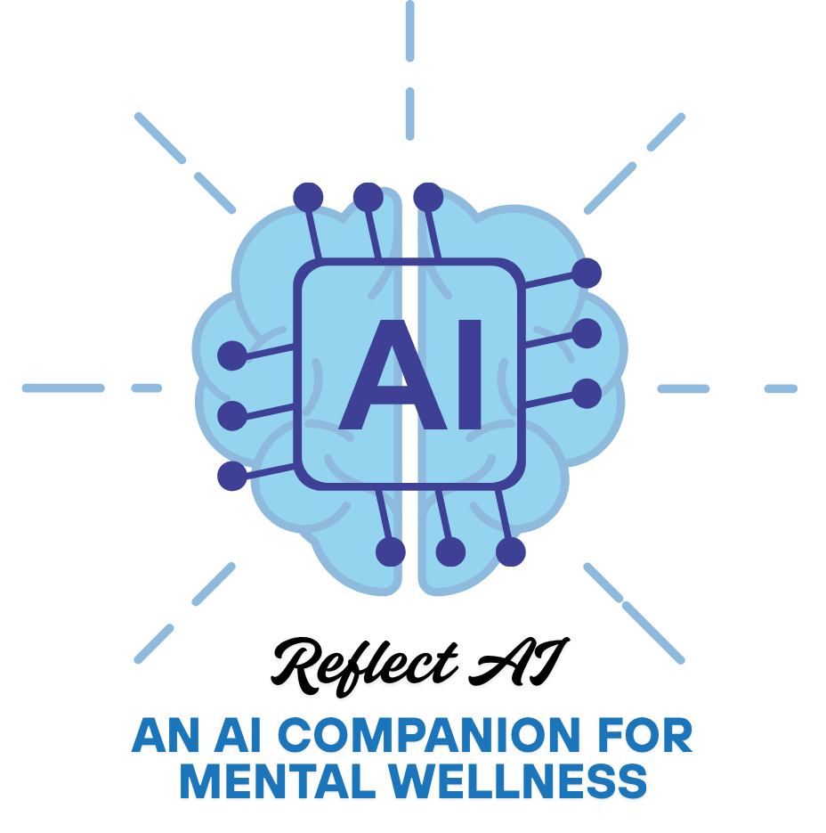

Reflect AI

An AI-Powered Mental Health Companion

GOPIKASHREE PR | IV- AI&DS | 7th SEM

# Abstract

Reflect AI is an AI-powered web application designed to support users' mental well-being through emotion detection, mood tracking, and personalized self-care recommendations. The system uses advanced Natural Language Processing (NLP) models such as BERT to analyze user messages and detect emotions like sadness, joy, anger, fear, and more. It stores these interactions in a local database, provides visualizations of emotional trends, and includes a basic admin panel for counselors to observe anonymized usage patterns.

## Objectives

• Detect stress, anxiety, or depression from user text input.

• Suggest personalized well-being tips and self-care activities.

• Track and visualize emotional states over time.

## Technologies Used:

|  |  |
| --- | --- |
| Layer | Technology |
| Frontend | Streamlit |
| Backend | Flask |
| NLP Model | BERT |
| Database | SQLite |
| Visualization | Plotly, Matplotlib |
| Others | Pandas, Numpy, TextBlob, VaderSentiment |

## KEY FEATURES

• **Emotion Detection:**  
Uses BERT to classify user messages into emotions with confidence scores.

• **Chat History Logging:**  
Every message, emotion, and timestamp is stored in an SQLite database.

• **Mood Trend Visualization:**  
Charts show emotion frequency and trends over time.

• **Emotion-Based Suggestions:**  
Based on detected emotion, self-care tips, quotes, or links are provided.

• **Filter by Emotion:**  
Users can filter their logs to review sadness, joy, etc.

## TESTING

• Unit tested emotion_analyser.py with multiple input types.

• Verified API responses using Postman and curl.

• Simulated varied chat inputs and validated emotional outputs.

• Cross-checked model predictions with known emotion-labeled sentences.

## SAMPLE VISUALS

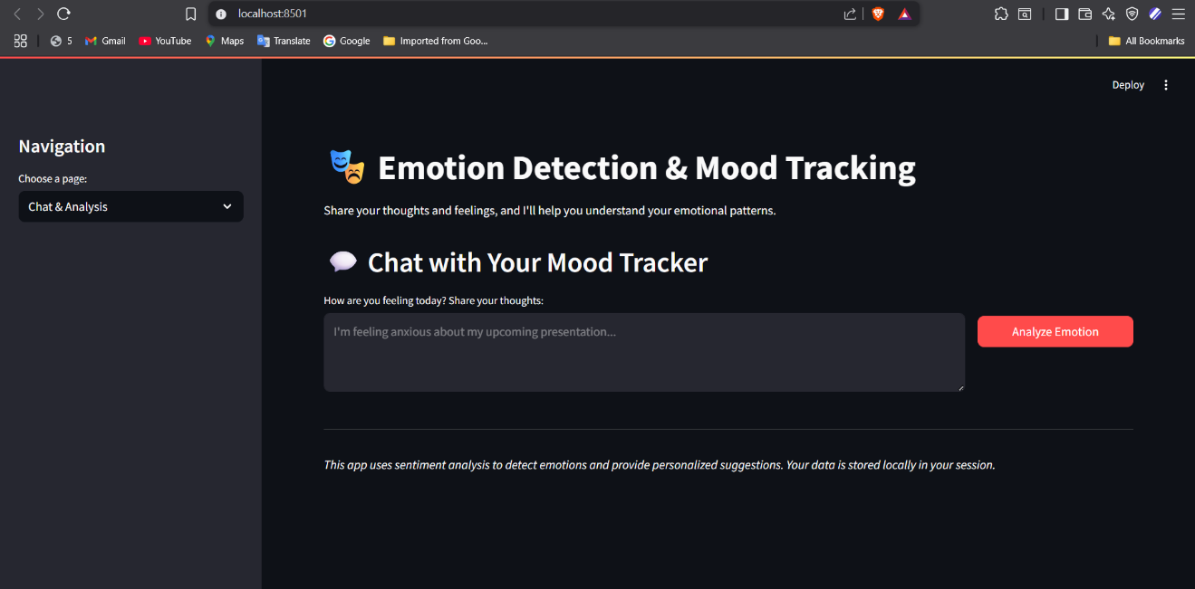

Fig 1: Chat with Reflect AI

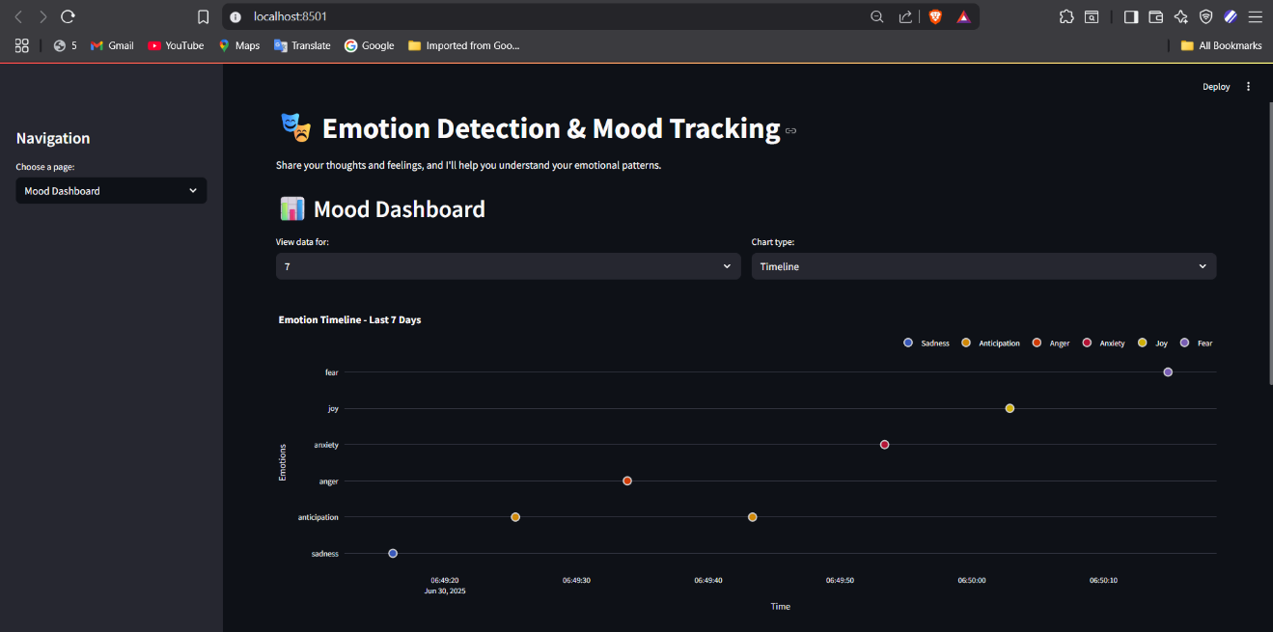

Fig 2: Mood Dashboard

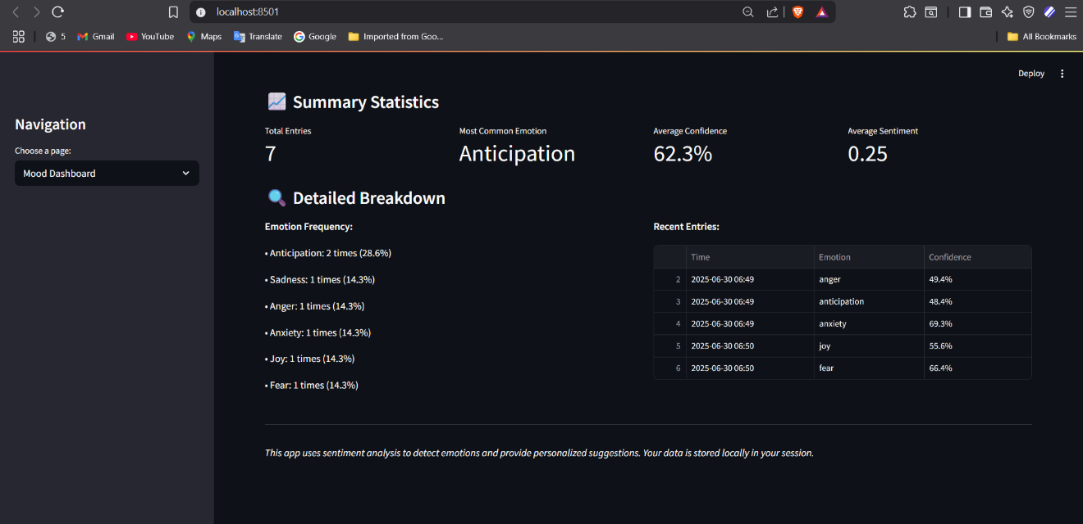

Fig 3: Summary statistics

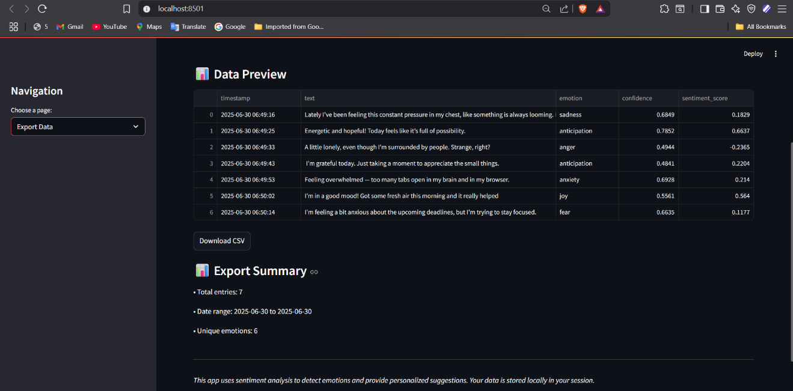

Fig 4: Previewing & Exporting data

## FUTURE SCOPE

• Voice tone analysis using Whisper + emotion detection

• User authentication and account-based emotion tracking

• Integration with wearable device APIs for physical + mental state analysis

• Push notifications with positive reinforcement messages

## CONCLUSION

Reflect AI offers a unique blend of AI, mental wellness, and data visualization. It demonstrates how technology can gently assist in emotional awareness and self-care, making it not just a technical project but a socially meaningful one.